**Profile of Dr. Manilal Valliyate**

In 2017, after more than 16 years of campaigning for animal rights, PETA India named as its new CEO, Dr Manilal Valliyate, former co-opted member of the Animal Welfare Board of India, which operates under the Ministry of Environment, Forest and Climate Change, and present member of the Kerala State Animal Welfare Board.

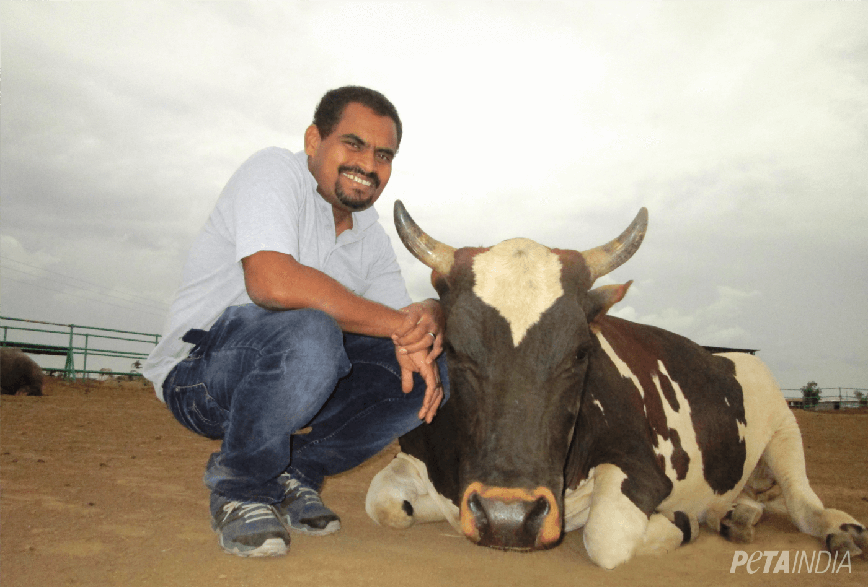

As PETA India’s director of veterinary affairs – a position Valliyate, who completed his education in veterinary science at Kerala Agricultural University, has held for the past seven years– he has already chalked up some of the organisation’s greatest victories. This includes getting the [**live embalming of calves banned in veterinary education**](https://www.petaindia.com/blog/new-indian-veterinary-education-regulations-end-calf-killing-reduce-cruelty/?utm_campaign=1216%20end%20calf%20killing%20&utm_source=PETAIndia%20Text&utm_medium=General); encouraging the central Department of Animal Husbandry to [**issue a circular**](https://www.petaindia.com/blog/several-states-to-implement-painless-cattle-castration/) to animal husbandry directors in all states and union territories stating that cattle must be given anaesthetics prior to castration; [**stopping illegal bullock cart races**](https://www.petaindia.com/blog/peta-awbi-stop-illegal-kila-raipur-bull-races-2/) in which the animals are commonly hit with nail-studded sticks; [**replacing the bullocks who hauled heavy kerosene oil carts through Mumbai streets with motorised transport**](https://www.petaindia.com/media/following-peta-campaign-maharashtra-government-stops-use-bullock-carts-transport-kerosene/); [**rescuing several once-chained elephants from lives of loneliness in temples**](https://www.petaindia.com/blog/victory-gajraj-is-free/); removing numerous lame and injured horses from the abusive [**Victoria carriage trade**](http://www.dnaindia.com/mumbai/report-injured-horse-rescued-by-peta-members-2151288/); and much more. His expert testimony and reports have helped PETA India win numerous court cases that have helped prevent suffering to animals nation-wide, including the landmark 2014 Supreme Court judgement that [**banned jallikattu**](https://www.petaindia.com/blog/peta-rejoices-supreme-court-upholds-ban-use-bulls-jallikattu/)(later permitted in Tamil Nadu, which PETA India is committed to challenging in court), bullock cart races, and other uses of bulls in performances.

To protect his health and reduce animal suffering, Valliyate lives and advocates a vegan lifestyle, opting for soya milk and [**peanut curd**](https://sharan-india.org/recipes/peanut-curd/) instead of foods made from cow or buffalo milk.

In 1998, Valliyate started his career as a teaching assistant at the College of Veterinary and Animal Sciences–Mannuthy and later worked as a veterinary surgeon for the Kerala State Animal Husbandry Department. He also worked as manager of veterinary services at Brooke Hospital for Animals, a leading welfare charity helping working equines, before joining PETA India. He possesses a post-graduate degree in business administration and a post-graduate degree in environmental laws and policy.